NAME:S.Krishna Chaithanya
REG NO:192424287
21. Swap Cases of a Specified Character Column in Data Frame Date:16-06-2026
Aim:
To write a Pandas program to swap the cases of a specified character column in a given Data Frame.
Algorithm:
- Start the program.
- Import the Pandas library.
- Create a Data Frame with student details.
- Display the original Data Frame.
- Select the specified character column.
- Apply str.swapcase() to swap uppercase to lowercase and lowercase to uppercase.
- Display the updated Data Frame.
- Stop the program.
Code:
import pandas as pd
data = {
'Name': ['Anu', 'BALA', 'Charan', 'divya'],
'Department': ['CSE', 'IT', 'ECE', 'EEE']
}
df = pd.DataFrame(data)
print("Original DataFrame:")
print(df)
df['Name'] = df['Name'].str.swapcase()
print("\nDataFrame after swapping case:")
print(df)

output:
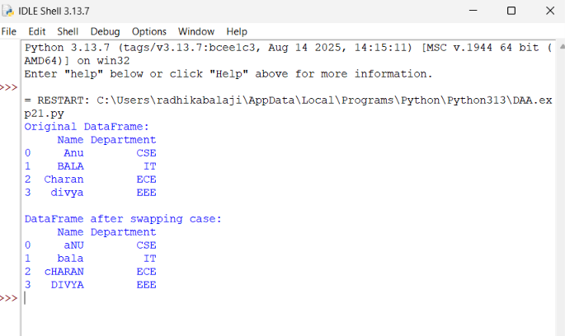
Result:
Thus, the Pandas program swaps the cases of the specified character column successfully.

22. Draw a Line with Labels and Title Date:16-06-2026
Aim:
To write a Python program to draw a line graph with suitable x-axis label, y-axis label, and title.
Algorithm:
- Start the program.
- Import matplotlib.pyplot.
- Create x-axis values and y-axis values.
- Draw the line using plt.plot().
- Add x-axis label using plt.xlabel().
- Add y-axis label using plt.ylabel().
- Add title using plt.title().
- Display the graph using plt.show().
- Stop the program.
Code:
import matplotlib.pyplot as plt

x = [0, 10, 20, 30, 40, 50]
y = [0, 30, 60, 90, 120, 150]
plt.plot(x, y)
plt.xlabel("x - axis")
plt.ylabel("y - axis")
plt.title("Draw a line")
plt.show()

output:
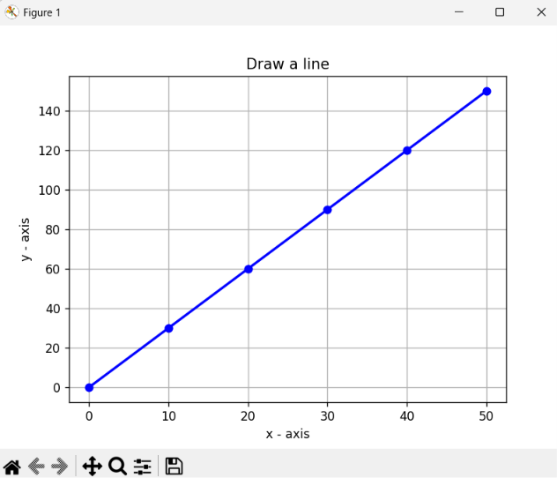
Result:
Thus, the Python program draws a line graph with suitable x-axis label, y-axis label, and title successfully.

23. Draw a Line Using Axis Values from a Text File Date:16-06-2026
Aim:
To write a Python program to read x-axis and y-axis values from a text file and draw a line graph with suitable labels and title.
Algorithm:
- Start the program.
- Import matplotlib.pyplot.
- Create a text file named test.txt with x and y values.
- Read the values from the file.
- Store x values in one list and y values in another list.
- Plot the line graph using plt.plot().
- Add x-axis label, y-axis label, and title.
- Display the graph.
- Stop the program.
Code:
import matplotlib.pyplot as plt

file = open("test.txt", "w")
file.write("1 2\n")
file.write("2 4\n")
file.write("3 1\n")
file.close()

x = []
y = []

file = open("test.txt", "r")

for line in file:
a, b = line.split()
x.append(int(a))
y.append(int(b))

file.close()

plt.plot(x, y)

plt.xlabel("x - axis")
plt.ylabel("y - axis")
plt.title("Sample graph!")

plt.show()
Output:
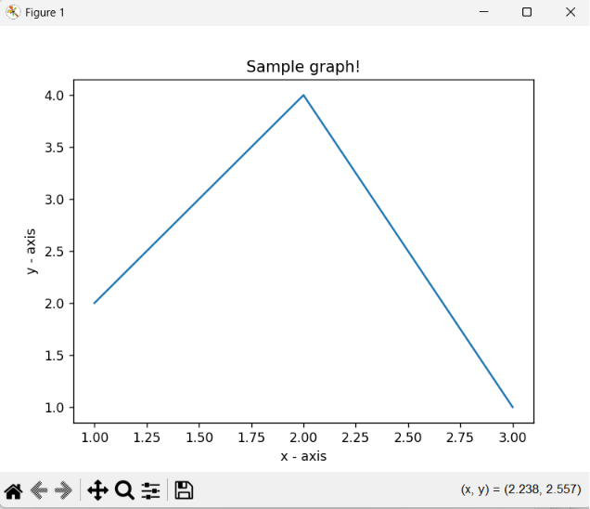
Result:
Thus, the Python program reads the axis values from the text file and successfully draws a line graph.

24. Draw Line Charts of Alphabet Inc. Financial Data Date:17-06-2026
Aim:
To write a Python program to draw line charts of the financial data of Alphabet Inc. between October 3, 2016 and October 7, 2016 using data from a CSV file.
Algorithm:
- Start the program.
- Import Pandas and Matplotlib libraries.
- Create a CSV file containing the financial data.
- Read the CSV file using Pandas.
- Extract the Date and Close columns.
- Plot a line chart using Date on the x-axis and Close price on the y-axis.
- Add x-axis label, y-axis label, and title.
- Display the chart.
- Stop the program.
Code:
import pandas as pd
import matplotlib.pyplot as plt

# Create fdata.csv
f = open("fdata.csv", "w")
f.write("Date,Open,High,Low,Close\n")
f.write("10-03-16,774.25,776.065002,769.5,772.559998\n")
f.write("10-04-16,776.030029,778.710022,772.890015,776.429993\n")
f.write("10-05-16,779.309998,782.070007,775.650024,776.469971\n")
f.write("10-06-16,779,780.47998,775.539978,776.859985\n")
f.write("10-07-16,779.659973,779.659973,770.75,775.080017\n")
f.close()

# Read CSV file
df = pd.read_csv("fdata.csv")

# Plot all financial data
plt.plot(df['Date'], df['Open'], label='Open')
plt.plot(df['Date'], df['High'], label='High')
plt.plot(df['Date'], df['Low'], label='Low')
plt.plot(df['Date'], df['Close'], label='Close')

plt.xlabel('Date')
plt.ylabel('Price')
plt.title('Alphabet Inc. Financial Data')

plt.legend()
plt.show()
Output:
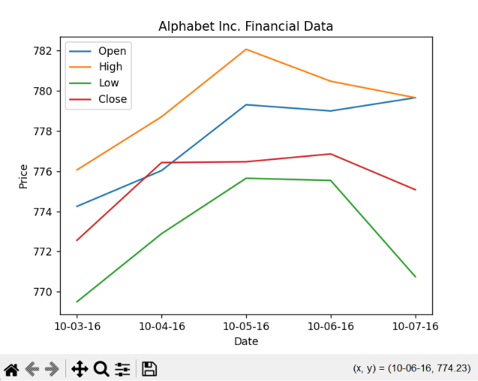
Result:
Thus, the Python program successfully reads the financial data from the CSV file and displays a line chart showing the closing prices of Alphabet Inc. from October 3, 2016 to October 7, 2016.
25. Plot Two or More Lines with Legends, Different Widths and Colors Date:17-06-2026
Aim:
To write a Python program to plot two or more lines with legends, different colors, and line widths.
Algorithm:
- Start the program.
- Import matplotlib.pyplot.
- Create x-axis and y-axis values for two lines.
- Plot the first line with a specified color and width.
- Plot the second line with a different color and width.
- Add labels for x-axis and y-axis.
- Add a title and legend.
- Display the graph.
- Stop the program.
Code:
import matplotlib.pyplot as plt

x = [10, 20, 30]

y1 = [20, 40, 10]
y2 = [40, 10, 30]

plt.plot(x, y1, color='blue', linewidth=3,
label='line1-width-3')

plt.plot(x, y2, color='red', linewidth=5,
label='line2-width-5')

plt.xlabel('x - axis')
plt.ylabel('y - axis')

plt.title('Two or more lines with different widths and colors with suitable legends')
plt.legend()
plt.show()
Output:
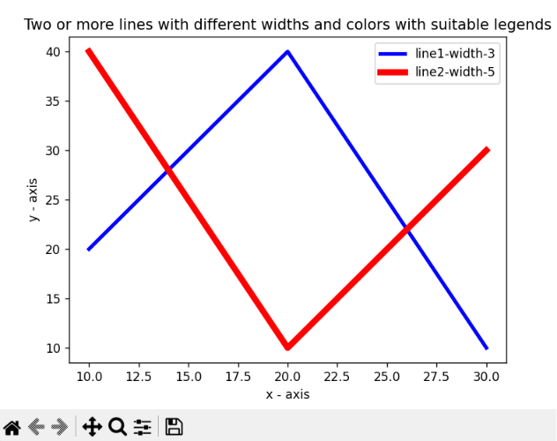
Result:
Thus, the Python program successfully plots two lines with different colors, line widths, and legends.

26. Create Multiple Plots Date:17-06-2026
Aim:
To write a Python program to create multiple plots using Matplotlib.
Algorithm:
- Start the program.
- Import matplotlib.pyplot.
- Create a figure.
- Divide the figure into multiple subplots using subplot().
- Plot data in each subplot.
- Display all plots using show().
- Stop the program.
Code:
import matplotlib.pyplot as plt

plt.subplot(2, 1, 1)
plt.plot([1, 2, 3, 4])

plt.subplot(2, 3, 4)
plt.plot([1, 2, 3])

plt.subplot(2, 3, 5)
plt.plot([3, 2, 1])

plt.subplot(2, 3, 6)
plt.plot([1, 3, 2])

plt.show()

Output:
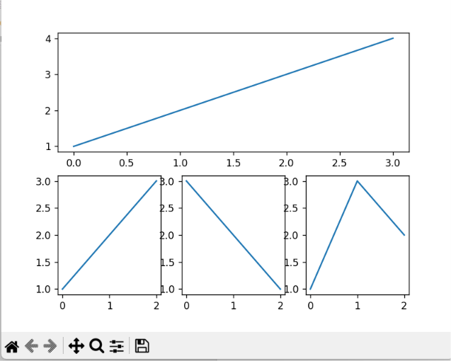
Result:
Thus, the Python program successfully creates multiple plots using subplots in a single figure.

27. Write a Python program to display a bar chart of the popularity of Programming Languages. Date:17-06-2026
Aim
To write a Python program to display a bar chart representing the popularity of different programming languages.
Algorithm
- Import the matplotlib.pyplot module.
- Create a list of programming languages.
- Create a list of popularity values.
- Use the bar() function to create a bar chart.
- Add chart title and axis labels.
- Display the chart using show().
- End the program.
Program
import matplotlib.pyplot as plt
languages = ['Java', 'Python', 'PHP', 'JavaScript', 'C#', 'C++']
popularity = [22.2, 17.6, 8.8, 8.0, 7.7, 6.7]
plt.bar(languages, popularity)
plt.title("Popularity of Programming Languages")
plt.xlabel("Programming Languages")
plt.ylabel("Popularity")
plt.show()
Output:
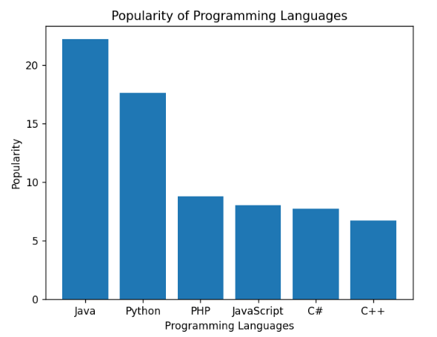
Result
Thus, the Python program to display a bar chart of the popularity of programming languages was executed successfully and the output was obtained.

28. Write a Python program to display a horizontal bar chart of the popularity of Programming Languages. Date:18-06-2026
Aim
To write a Python program to display a horizontal bar chart representing the popularity of different programming languages.
Algorithm
- Import the matplotlib.pyplot module.
- Create a list of programming languages.
- Create a list of popularity values.
- Use the barh() function to create a horizontal bar chart.
- Add chart title and axis labels.
- Display the chart using show().
- End the program.
Program
import matplotlib.pyplot as plt
languages = ['Java', 'Python', 'PHP', 'JavaScript', 'C#', 'C++']
popularity = [22.2, 17.6, 8.8, 8.0, 7.7, 6.7]
plt.barh(languages, popularity)
plt.title("Popularity of Programming Languages")
plt.xlabel("Popularity")
plt.ylabel("Programming Languages")
plt.show()

Output:
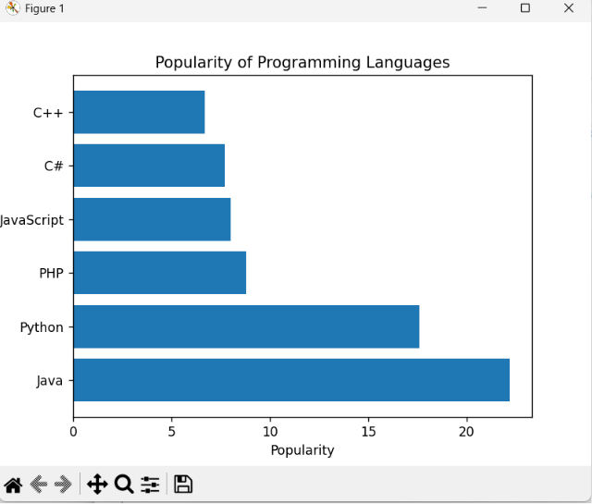
Result
Thus, the Python program to display a horizontal bar chart of the popularity of programming languages was executed successfully and the required output was obtained.

29. Write a Python program to display a bar chart of the popularity of Programming Languages using different colors for each bar. Date:18-06-2026
Aim
To write a Python program to display a bar chart of programming language popularity using different colors for each bar.
Algorithm
- Import the matplotlib.pyplot module.
- Create a list of programming languages.
- Create a list of popularity values.
- Create a list of colors for the bars.
- Use the bar() function with the color parameter.
- Add title and axis labels.
- Display the chart using show().
- End the program.
Program
import matplotlib.pyplot as plt
languages = ['Java', 'Python', 'PHP', 'JavaScript', 'C#', 'C++']
popularity = [22.2, 17.6, 8.8, 8.0, 7.7, 6.7]
colors = ['red', 'blue', 'green', 'orange', 'purple', 'brown']
plt.bar(languages, popularity, color=colors)
plt.title("Popularity of Programming Languages")
plt.xlabel("Programming Languages")
plt.ylabel("Popularity")
plt.show()

Output:

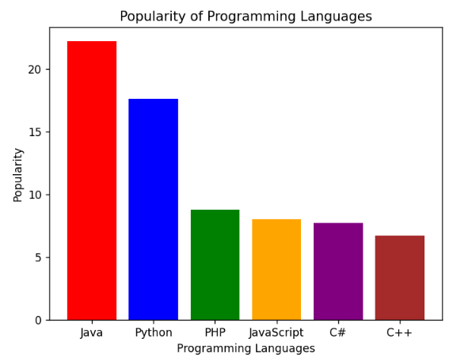

Result
Thus, the Python program to display a bar chart of the popularity of programming languages using different colors for each bar was executed successfully and the required output was obtained.

30. Write a Python program to create a bar plot of scores by group and gender using multiple X values on the same chart for men and women. Date:18-06-2026
Aim
To write a Python program to create a grouped bar chart showing scores of men and women for different groups.
Algorithm
- Import matplotlib.pyplot and numpy.
- Create arrays for men's and women's scores.
- Create positions for the groups on the X-axis.
- Set the width of each bar.
- Plot bars for men and women side by side.
- Add labels, title, and legend.
- Display the chart using show().
- End the program.
Program
import matplotlib.pyplot as plt
import numpy as np
men_means = (22, 30, 35, 35, 26)
women_means = (25, 32, 30, 35, 29)
groups = np.arange(5)
width = 0.35
plt.bar(groups, men_means, width, label='Men')
plt.bar(groups + width, women_means, width, label='Women')
plt.xlabel('Groups')
plt.ylabel('Scores')
plt.title('Scores by Group and Gender')
plt.xticks(groups + width/2, ('G1', 'G2', 'G3', 'G4', 'G5'))
plt.legend()
plt.show()

Output:
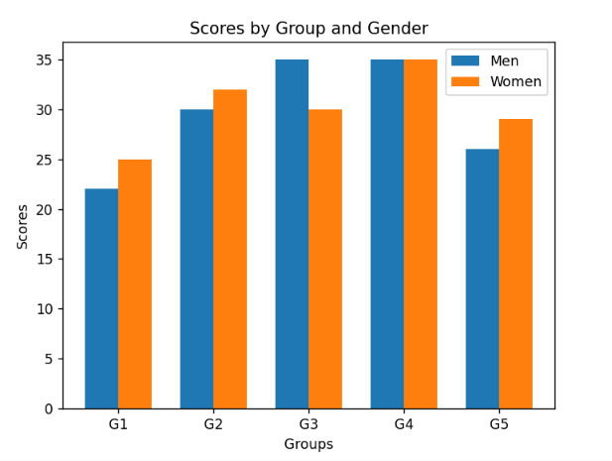
Result
Thus, the Python program to create a grouped bar chart of scores by group and gender was executed successfully and the required output was obtained.

31.

